Getting started
1. Insert a Disc 3. Enter your key.
Choose 32 bit. If You’re not sure, You’ll find it on back of product
Start with 32. We’ll let you know if you Key Card. We’ll walk you through
Need to switch the rest.
2. Follow the steps. Find tips and how –to videos to
If you don’t see them on screen, open help you get to know Windows 8:
Your Start Menu or Windows Explorer www.windows.com/support
Then select Computer. Now Select DVD
Setup.
Getting around
Move your mouse into the upper-right corner to use the charm bar to open Start, search your PC and Change your setting.
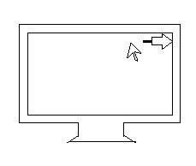
c 2012 MicrosoftX18-06123-01 PSGA

